Chapter 9, Problem 26.

The loop equation for a series RLC circuit gives

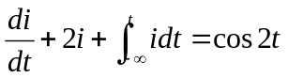

Assuming that the value of the integral at t = -∞ is zero, find i(t) using the phasor method.

